Basic Programming and Networks
Lab Sheet 01
Code:Blocks
Code: Blocks is a free, open-source cross-platform IDE that supports multiple compilers including GCC, Clang and Visual C++. It is developed in C++ using wxWidgets as the GUI toolkit. Using a plugin architecture, its capabilities and features are defined by the provided plugins. Currently, Code: Blocks is oriented towards C, C++, and Fortran. It has a custom build system and optional Make support.
How to install Code: Blocks?
- Go to http://www.codeblocks.org/
This page will be appeared.
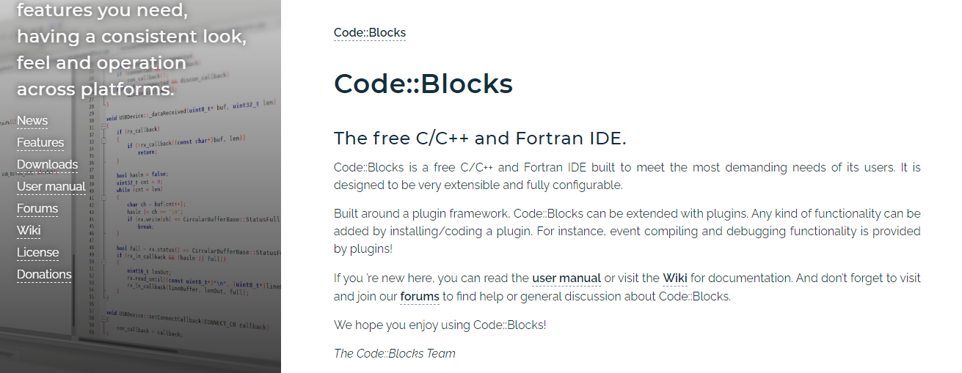
- Then click on Downloads
This page will be appeared.
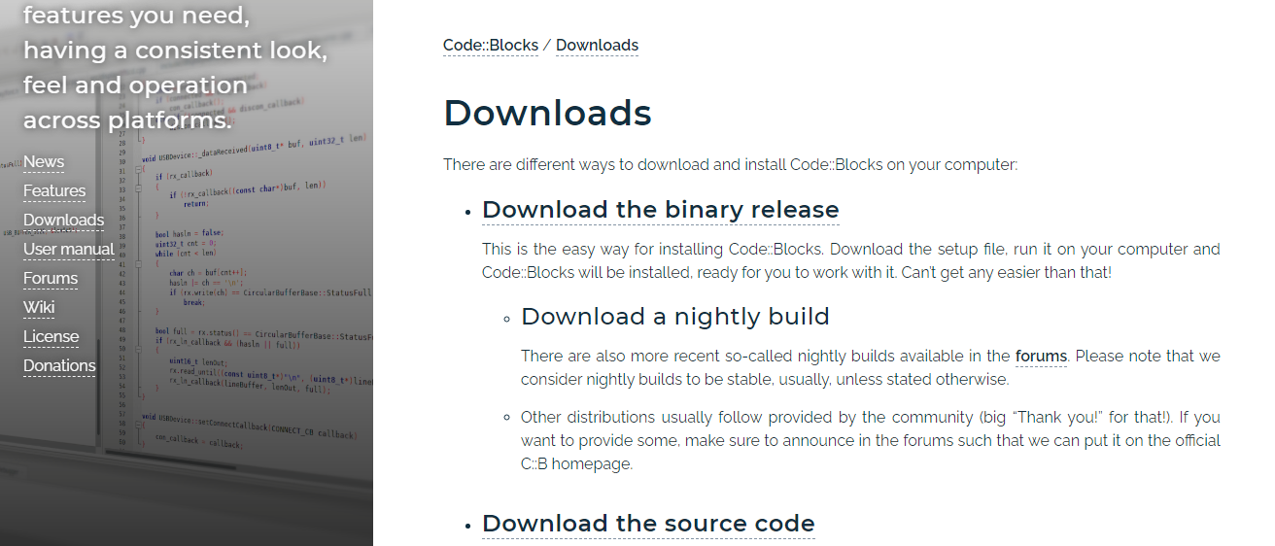
- Click on Download the binary release
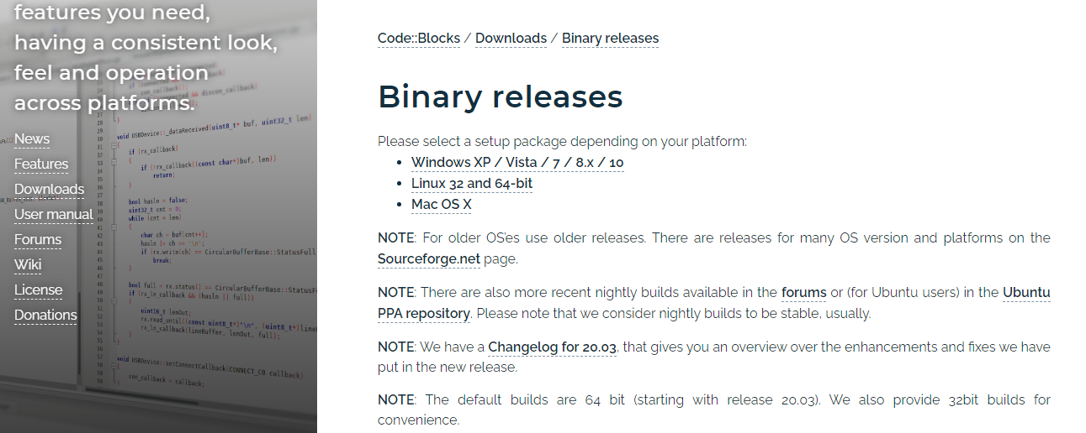
- Click on Windows XP / Vista / 7 / 8.x / 10
You will be directed to Windows versions as follows.
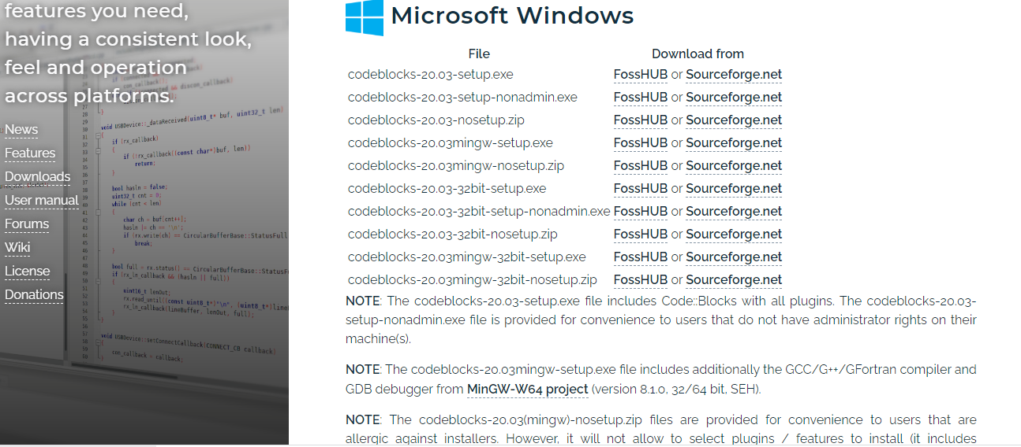

- Then click on codeblocks-20.03mingw-setup.exe FossHUB or Sourceforge.net
- Set-up file will be downloaded automatically.
- Run the set up file.

